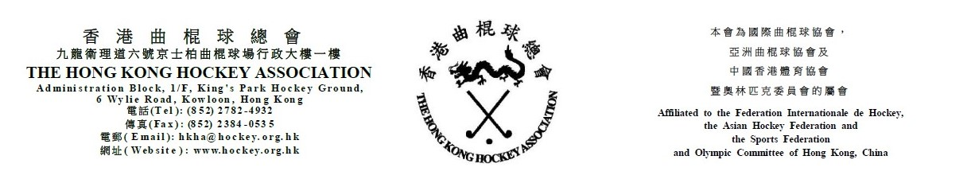

Attendance Form for
The Hong Kong Hockey Association
8th Annual General Meeting
on Thursday, 29 July 2021

(Please see notes below before completing the form)
The following is authorized to represent __________________________________ (Member Club) and to vote at the HKHA AGM on Thursday, 29 July 2021.

_____________________________________
(Name)
Note: Owing to the COVID-19 pandemic, one representative from each club is invited to attend the HKHA AGM.

(Name of Club Official) |  | (Signature of Club Official)

(Position of Club Official) |  | (Date)

Notes: (1) Club officials include President, Chairman, Hon. Secretary, Convenor and Hockey Section Captain.
- This form must be received by the HKHA office no later than Thursday, 22 July 2021.

